

__________________________________________________________________________

Camp Oak Hill, Oxford, NC

Event Dates:
- November 8-10, 2019 (Friday-Sunday).
- Most volunteers will arrive Friday evening after work or school, but those who can, are welcome to arrive Thursday evening.
- If you can’t spend the night you are welcome to arrive Saturday morning.
- We will depart for home after our on-site Sunday morning Worship Service.

Location: 1528 Oak Hill Rd., Oxford, NC 27565

Description of the Ministry: Camp Oak Hill is a non-denominational Christian camp. Founded in 1976, the camp occupies 27 acres in northern Granville County. The Camp also operates year round as a retreat center. The SWAT Team has held events at Camp Oak Hill numerous times. It is a great “family event”.
www.campoakhill.org
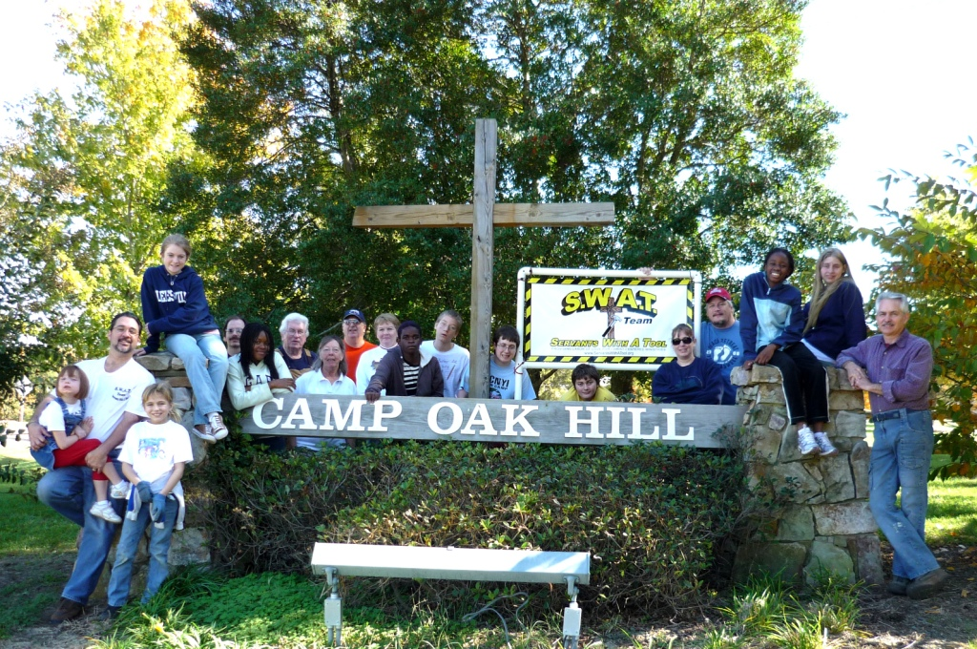
Work Projects:

- Painting
- Build benches
- Repair broke fence posts
- Replace fence posts
- Rake leaves
- Clearing out brush and small trees

Tools To Bring:
- Carpentry tools
- Gloves, yard and garden tools

Food:
- Meals will be provided for the Team. We must know how many will be present from your family and exactly what meals you will be eating.
- Bring your own snacks and/or special diet items.

Lodging:
- We will sleep in dorms with 16 bunks each.
- Bring your own bed linens and bath supplies (towels, soap, etc.)
- RV’s can park and hook up next to the infirmory.

Please let Steve Blakeman know when you will arrive.

Steveblakeman@Earthlink.net

Phone: 919-368-277

